USER ACCEPTANCE TEST PLAN
[Filter export report production daily- STARS]

VERSION 1.1
As OF Desember 07, 2021

 | Underwriting | Underwriting
Signature | 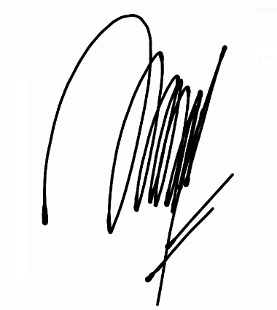 | 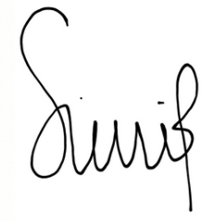
Printed Name | Nurwaidah | Wuri Wulandari
Position | Senior Manager Head of Underwriting | Assistant Manager Underwriting
Date

 | 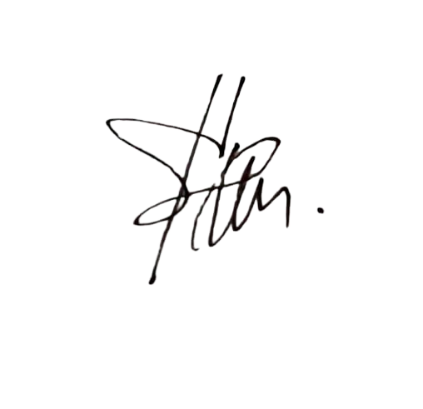  IT Business Analyst | IT Division Head | IT Developer – Developer | IT Developer – Coordinator / Leader
Signature | 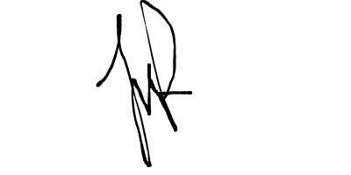 |  | 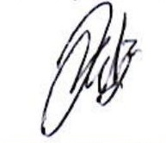 | 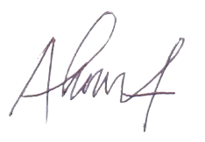
Printed Name | Januar Aransyah | Ateng Moch. Yasin Rachim | Andez | Ahmad Zulfahmi
Position | Head Of IT Business Analyst | Head of IT | IT Development | Head of IT Development
Date

Document History

Version | Issue Date | Change Description | Initial | Reviewer / Logic Inspector | Approver | Approver | Approver
V 1.1

Contact for Enquiries

If you have any questions regarding this document, please contact:
Name : Januar Aransyah
Title : Business Analyst
Ext. : 1118
E-mail : januar.aransyah@takaful.com

Table of Content
1. UAT Environment 4
2. UAT Scenario 5
3. SCREEN SHOOT 8
4. OPEN ISSUES 12
5. UAT Person In Charge 22

1. UAT Environment
Testing Address : | https://starsba.takaful.com/
Description : | UAT Filter Export Report Production Daily – STARS
Prepared By : |  | Reviewed By :
UAT From : | <Desember> <07>, <2021>
UAT To : | <Desember> <10>, <2021>
UAT Creator & Execute | Januar Aransyah
Testing User | Pengecekan Hasil export filter report Production Daily
Nurwaidah | UAT-STARS
Wuri Wulandari
Scope : | - Report Production Daily

2. UAT Scenario

No | Scenarios | Expected Result | Actual Result | Defect / Remark | Pass / Fail
1 | Filter data by Tanggal dan Status Cancel | Data peserta tampil pada file export | As expected |  | Pass
2 | Filter data by Tanggal | Menampilkan pesan error harus memilih status yang akan di Tarik | As Expected |  | Pass
3 | Filter data by Tanggal dan Status Approve dan Inforce | Data peserta tampil pada file export | As Expected |  | Pass
4 | Filter data by Tanggal dan All Status | Data peserta tampil pada file export | As Expected |  | Pass

3. SCREEN SHOOT
- Filter data by Tanggal dan Status Cancel

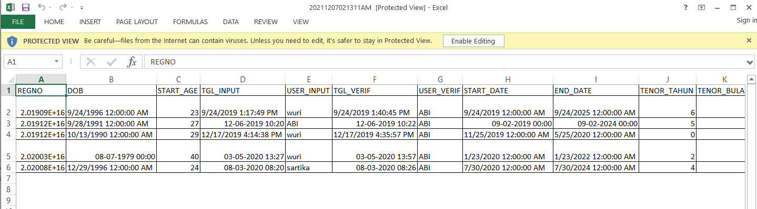

2. Filter data by Tanggal

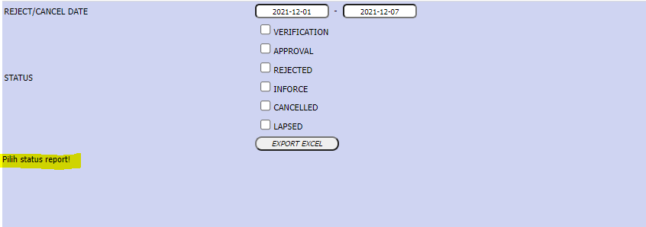

3. Filter data by Tanggal dan Status Approve dan Inforce
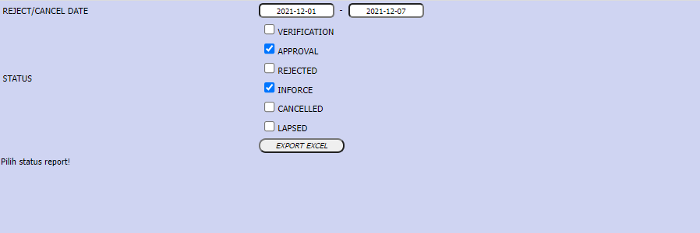

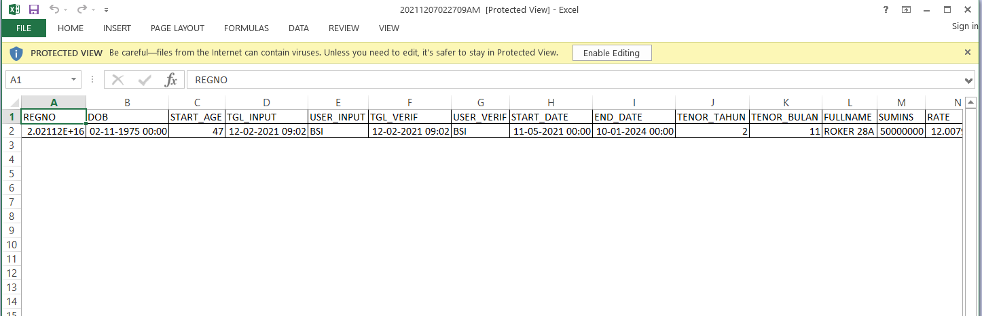

4. Filter data by Tanggal dan All Status
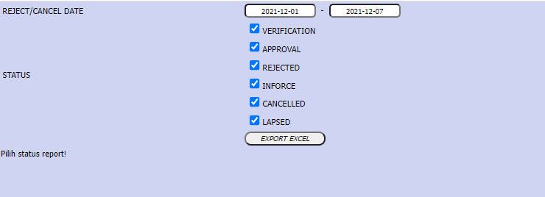

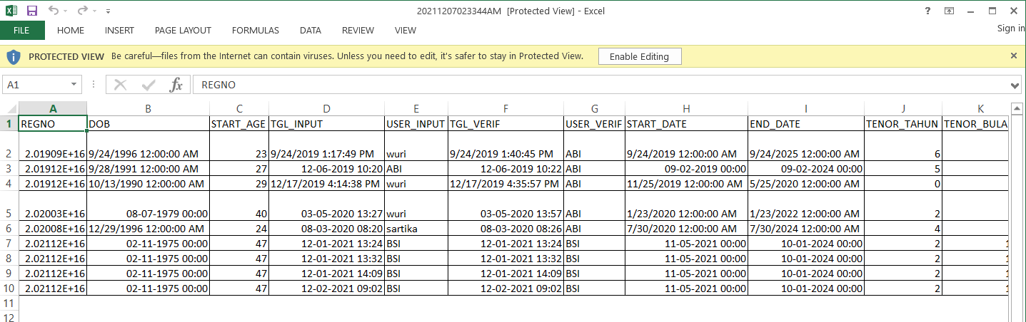
4. OPEN ISSUES
No | Name | Notes
5. UAT Person In Charge
No | Name | Level | Position
1 | Januar Aransyah | Manager | Business Analyst
2 | Nurwaidah | Senior Manager | Underwriting

